**Experiment 7**

**Rajneesh Prajapati : 500110709**

**Aim : Using Angular JS Implement Input Validation**

**Objective :**

1. Implement input validation in AngularJS to dynamically change textbox background color based on user input.
2. Develop a cost calculator feature using AngularJS for efficient computation of costs.
3. Create a search filter functionality in AngularJS to enable users to search and display filtered lists based on their queries.

**Theory :**

AngularJS facilitates robust input validation, enabling real-time background color changes based on user input. Cost calculators can be efficiently implemented, and search filters enhance user experience by enabling dynamic list filtering based on user queries, enhancing usability and functionality.

**-- Question 1: Code to change the background of the textbox based on the color mentioned by the user.**

<!DOCTYPE html>

<html>

<head>

<title>AngularJS Input Validation</title>

<script src="https://ajax.googleapis.com/ajax/libs/angularjs/1.8.2/angular.min.js"></script>

<script src="app.js"></script>

<link rel="stylesheet" type="text/css" href="styles.css">

</head>

<body ng-app="myApp">

<div ng-controller="MainController">

<input type="text" ng-model="color" ng-style="{'background-color': color}" placeholder="Enter color name">

</div>

</body>

</html>

// app.js

var app = angular.module('myApp', []);

app.controller('MainController', function($scope) {

});

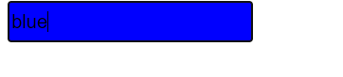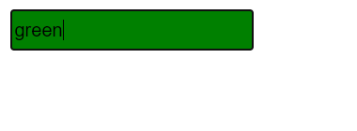

**-- Question 2: Code to create a cost calculator.**

<!DOCTYPE html>

<html>

<head>

<title>Cost Calculator</title>

<script src="https://ajax.googleapis.com/ajax/libs/angularjs/1.8.2/angular.min.js"></script>

<script src="app.js"></script>

<link rel="stylesheet" type="text/css" href="styles.css">

</head>

<body ng-app="myApp">

<div ng-controller="MainController">

<input type="number" ng-model="quantity" placeholder="Enter quantity"><br>

<input type="number" ng-model="price" placeholder="Enter price per item"><br>

Total cost: {{quantity * price | currency}}

</div>

</body>

</html>

// app.js

var app = angular.module('myApp', []);

app.controller('MainController', function($scope) {

});

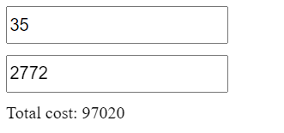

**-- Question 3: Code to build a simple search filter functionality:**

<!DOCTYPE html>

<html>

<head>

<title>Search Filter</title>

<script src="https://ajax.googleapis.com/ajax/libs/angularjs/1.8.2/angular.min.js"></script>

<script src="R.js"></script>

<link rel="stylesheet" type="text/css" href="Rx.css">

</head>

<body ng-app="R">

<div ng-controller="RController">

<input type="text" ng-model="RxSearch" placeholder="Search">

<ul>

<li ng-repeat="item in RxItems | filter:RxSearch">{{item}}</li>

</ul>

</div>

</body>

</html>

// Rx.js

var RxApp = angular.module('wasiApp', []);

RxApp.controller('WasiController', function($scope) {

$scope.wasiItems = [

'Galaxy S21',

'Galaxy Tab S7',

'Galaxy Watch',

'Samsung Notebook 9',

'Galaxy Buds Pro',

'Samsung Odyssey G9 Monitor',

'Samsung Galaxy Book Flex'

];

});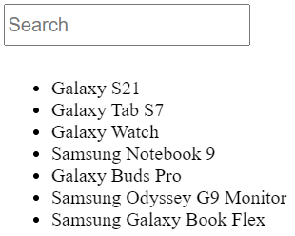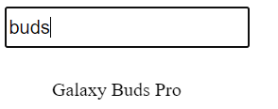

**-- Question 4: Code to use AngularJS Tables:**

<!DOCTYPE html>

<html>

<head>

<title>AngularJS Tables</title>

<script src="https://ajax.googleapis.com/ajax/libs/angularjs/1.8.2/angular.min.js"></script>

<script src="Rx.js"></script>

<link rel="stylesheet" type="text/css" href="Rx.css">

</head>

<body ng-app="RxApp">

<div ng-controller="RxController">

<table>

<thead>

<tr>

<th>ID</th>

<th>Name</th>

</tr>

</thead>

<tbody>

<tr ng-repeat="item in RxItems">

<td>{{item.id}}</td>

<td>{{item.name}}</td>

</tr>

</tbody>

</table>

</div>

</body>

</html>

// Rx.js

var RxApp = angular.module('wasiApp', []);

wasiApp.controller('WasiController', function($scope) {

$scope.wasiItems = [

'Galaxy S21',

'Galaxy Tab S7',

'Galaxy Watch',

'Samsung Notebook 9',

];

});

